S.T.E.P. U.P.

Action

Plan

My Profile

My Name  Include your full name and nickname |  | My Family and Friends  List those you are close to |  | My Community (support)  e.g. Teacher, Coach, Case Manager

Three Positive Words That Describe You
Refer to ‘My Career Match’ document page 8.
1) Paid employment, volunteering or work experience:
2) Occupations I am interested in:
3) Work experience I’d like to do:
4) Two referees (name, ph#, position):

(

My Current Skills and Abilities
(Things that I can do well, e.g. listening, team work, problem-solving)
My Values (Things that are important to me, e.g. Integrity, hard-working, caring for the environment, adventure. Refer to the VIA Character Quiz for a List of Your Personal values)
Things I Enjoy

My Achievements
The recent successes/achievements I’ve had in my life:
(they could be personal victories that mean something to just you)

They Made me feel:

I discovered about myself that:

This changed my outlook and goals because:

This changed my outlook and goals because:

How The Heck Does SACE Work?!

- The SACE is made up of two parts:
Stage 1 (which most students do in Year 11) and
Stage 2 (which most students do in Year 12).

- You need to get 200 credits to achieve the SACE, through a mixture of compulsory and free-choice subjects and courses.

- To be awarded the certificate, you will need to achieve a C grade or better for the compulsory Stage 1 subjects — the Personal Learning Plan and English and mathematics subjects.
- You will also need to achieve a C– grade or better in 60 credits of Stage 2 subjects and in 10 credits for the Research Project.

- The other subjects and courses span a wide range of learning areas: Arts; Business, Enterprise, and Technology; English; Languages; Health and Physical Education; Humanities and Social Sciences; Mathematics; and Sciences

Your Subject Choices

- All SACE students need to complete the compulsory requirements, but your other subject choices are up to you. Check them out here: http://www.northernadelaidesc.sa.edu.au/curriculum/course-guide/subjects-and-vet-courses/

- SACE subjects that are worth 10 credits are usually one-semester subjects, while 20-credit subjects usually involve a full year of study.

- When deciding on your subjects for Year 11 and Year 12, remember to consider any prerequisite subjects for tertiary courses of your interest. It may be best to study Stage 1 of a subject to be successful in Stage 2 of the subject.

Stage 1 and Stage 2 Explained
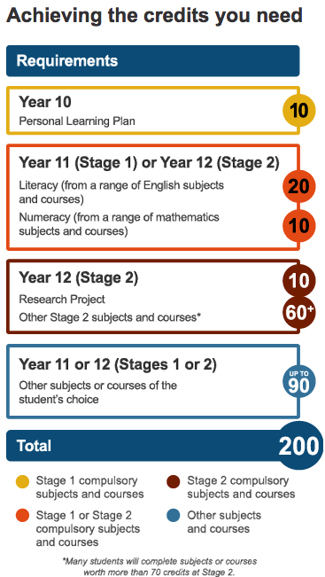
- Students start the SACE with the Personal Learning Plan (PLP). The PLP is a 10-credit Stage 1 subject and all students need to achieve a C grade or better in this subject to get their SACE. Studying the PLP gives you a good foundation for your Year 11/Stage 1 and Year 12/Stage 2 studies, and can help in your subject selection.

- You can choose from a range of Stage 1 subjects offered at your school, as well as vocational education and training (VET) courses and other options.

- There are two compulsory requirements for the SACE that students usually complete at Stage 1 — two English subjects (2 semesters) and at least a semester of a mathematics subject. You need to get a C grade or better in both.

- In Stage 2, you choose your subjects and courses from your school.

- There is one compulsory subject in Year 12 — the Research Project. It is a one-semester (10-credit) subject that gives you the chance to do in-depth research on a topic of your choice.

Map The Subjects You Need to Finish Your SACE
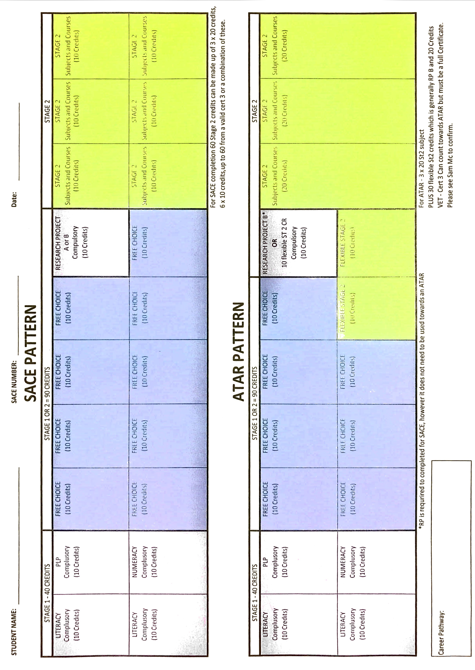

Vocational Education & Training (VET) I’d Like To Do

- Vocational education and training (VET) enables students to acquire skills and knowledge for work through a nationally recognised industry-developed training package or accredited course. VET is delivered, assessed, and certified by registered training organisations (RTOs).

- Undertaking VET may benefit students’ exploration of a variety of career pathways; it is not just reserved for a pathway within the trades (e.g. plumbing, automotive, and construction). Students can complete VET qualifications in a diverse range of industries, including business administration, veterinary nursing, aged care, or sport and recreation.

- VET is an excellent choice of study for many students. It always includes practical, hands-on learning, and it can lead to excellent jobs in many fields.

- Studying VET as part of the SACE gives students a head start on a qualification, which is a great way to fast-track progress towards a rewarding career, while also developing independence and time-management skills.

- The SACE Board’s recognition arrangements enable students to build meaningful pathways in the SACE through VET.

- The SACE enables students to include a significant amount of VET in their SACE studies. Students can gain recognition for up to 150 SACE credits at Stage 1 and/or Stage 2 for successfully completed VET.

What courses would you like to do?

- ________________________________________________________
How come? ________________________________________________________

- ________________________________________________________
How come? ________________________________________________________

- ________________________________________________________
How come? ________________________________________________________

Where is this study available? (who through? What institutions or RTO’s?)
________________________________________________________________________

________________________________________________________________________

Employment

- Looking for your first job or a new job? This can be an exciting time!

- To help ensure you get a proper deal when you start your job, it is important to find out about your rights and entitlements and what responsibilities you may have in the workplace.

- This best practice guide found at www.fairwork.gov.au/youngworkers explains:
  - things you need to know about your employment conditions
  - things you need to know before you start work
  - things you need to know when you start work
  - what protections you have against harassment and discrimination
  - union membership
  - the importance of workplace health and safety.

What Work options would you like:

- ________________________________________________________
How come? ________________________________________________________
- ________________________________________________________
How come? ________________________________________________________
- ________________________________________________________
How come? ________________________________________________________

Quick Quiz!

Doing stuff that involves more (circle): DOING --or-- THINKING/PLANNING --or-- TALKING

I like (circle): OUTSIDE --or-- INSIDE
I want to work/learn: NEAR HOME --or—I DONT MIND TRAVEL
I want to work/learn: ALONE --or-- SMALL GROUPS --or-- LARGE GROUPS
I like to work/learn where it’s: NOISY & BUSY --or—QUIET & STEADY
I like to spend time with: KIDS -or- ADOLESCENCE -or- ADULTS -or- ELDERLY
What days of the week are you prepared to work/learn: M T W Th F S S
Are you prepared to work weekends? YES –or-- NO
Are you a: EARLY BIRD –or-- NIGHT OWL?

What is your pet peeve, what would you NOT do no matter how much you were paid?
_________________________________________________________________________

If money wasn’t a problem, and you could do one thing that you weren’t going to get paid for, what would it be? ____________________________________________________________
__________________________________________________________________________

Why Volunteering Rocks
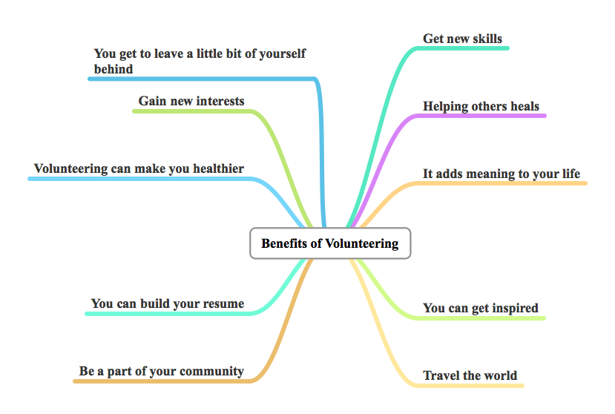

- A wide range of volunteering positions are always available
- From computing to administration, from looking after our environment to helping a local charity, from coaching sport to teaching someone to read ... volunteers make a vital contribution to all aspects of community life.

What Volunteering would you like to do?

- ________________________________________________________
How come? ________________________________________________________

- ________________________________________________________
How come? ________________________________________________________

- ________________________________________________________
How come? ________________________________________________________

Your Career Research
Once you have completed relevant career quizzes at www.yourlifeacademy.weebly.com sign into www.myfuture.edu.au and go to ‘Occupations’ to search for your chosen careers to investigate.

Career Choice #1: ______________________________
What Personal Traits or Qualities Do I Need? (patience, willingness, friendly etc.)
(See MyFuture Occupation “Pathways”Tab)
What Work Skills are required?
(See “Overview” Tab)

Who are some of the workplaces you could work for?
(Google businesses, YellowPages website or job ad websites)

What’s the employment outlook for this job?
(See joboutlook.gov.au, search your career and see ‘Prospects’ Tab)
What education/ training is required?
(See MyFuture Occupation “Pathways” Tab, then “Related Courses” on RHS)

What Education Providers offer the training I need?
(Note Names, upcoming open days, info sessions etc.)
What are the course/ training requirements or prerequisites?
What are the different paths to this career and options I can take?
(e.g. VET provider then University etc.)

Career Choice #2: ______________________________
What Personal Traits or Qualities Do I Need? (patience, willingness, friendly etc.)
(See MyFuture Occupation “Pathways”Tab)

What Work Skills are required?
(See “Overview” Tab)

Who are some of the workplaces you could work for?
(Google businesses, YellowPages website or job websites)

What’s the employment outlook for this job?
(See joboutlook.gov.au, search your career and see ‘Prospects’ Tab)
What education/ training is required?
(See MyFuture Occupation “Pathways” Tab, then “Related Courses” on RHS)

What Education Providers offer the training I need?
(Note Names, upcoming open days, info sessions etc.)
What are the course/ training requirements or prerequisites?
What are the different paths to this career and options I can take?
(e.g. VET provider then University etc.)

Why YOU Need A Portfolio

What Is a Portfolio?
- A portfolio is a display folder that shows off your work and abilities.
- A portfolio is a tool that you put together as you do more stuff that gives people who see it an idea of how awesome you are — your experience, your education, your accomplishments, and your skills.
- Not only does it show the employer who you are, but it also displays what you have the potential to become.
- It is designed to do one thing—to support you as you market yourself!

Top Five Reasons to Have a Portfolio
- Set yourself apart from the ‘competition’.
- Increase the work offer by impressing the interviewer.
- It is tangible proof of your abilities.
- It might help you get promoted.
- It can help you find the position that is right for you!

Where to Begin
- You should start developing your portfolio by first doing a self-assessment. Evaluate what you have to offer and what the best ways are to market your assets.
- If you have don't have much work experience—most students don't—you'll need to mine your school work, volunteer work, and hobbies for evidence of the relevant skills you know you have. For example, if you did event promotions for a organisation, include a copy of a flyer or poster you designed.

The following is a list of items you may want to include (TICK ONCE COMPLETE):
- Table of Contents (for easy reference)
- Traditional Résumé: A summary of your education, achievements, and work experience, using a chronological or functional format.
- Skills, Abilities and Marketable Qualities: A detailed examination of your skills and experience. This section should include the name of the skill area; the performance or behavior, knowledge, or personal traits that contribute to your success in that skill area; your background and specific experiences that demonstrate your application of the skill.
- Samples of Your Work: A sampling of your best work, including reports, papers, studies, brochures, projects, presentations, etc. Take photos of what you’ve done, even gardens you’ve built at home (horticulture/construction) or amazing meals you’ve made (hospitality). You can also include CD-ROMs, videos, and other multimedia formats.
- Testimonials and Letters of Recommendations: A collection of any kudos you have received–from customers, students, teachers, people in the community, employers etc. Some experts even suggest including copies of favorable school reports and reviews.
- Awards: A collection of any certificates of awards and scholarships.
- Conference and Workshops: A list of conferences, seminars, and workshops you've participated in and/or attended.
- Certificates, Transcripts and Licenses: A description of relevant courses, licenses, and certifications.
- Test Results: Document professional or school quiz and test results.
- Anything else that shows stuff you’ve done, are doing and are a part of!

Specifically, in your portfolio you could include:

PORTFOLIO PIECES | NOTES ON WHERE THIS IS UP TO
Cover Page and maybe content
Cover Letter
Resume (including 3 referees)
Make sure resume has Professional Email Address
Certificates
Good Reports/Feedback
Photos of work or evidence of your ability in the field (i.e. photos of hair styles if you want to become a hairdresser or the picture of the coffee table that you made if you want to become a carpenter) You might have written an awesome article for our schools magazine which you might include if you want to be a journalist. What is the evidence you are collecting that backs up why you should get the job or in to the course?
THINGS TO HAVE IN YOUR PERSONAL FOLDER TO HELP YOU PREPARE FOR WORK
Bank Account Details
Drivers License
Birth Certificate
School ID
DCSI Clearance (18+)
Run down of Computer Skills
Tax File Number
Work Experience Report
Portfolio of work you’ve done
Assessment Results:

- VAK Learning Style Quiz
- My Career Match
- VIA Values Assessment
- Strengths and Challenges
- Employability Skills Assessment
SACE Plan
WHS training (Passport2Safety)
USI Number (go to usi.gov.au)

Unfazed – Keeping Cool and Remaining Unbothered

How’s your stress right now (tick what applies):

- Do you eat more or less when stressed?
- Do you worry over relationships, money or health?
- Are any of your relationships causing you stress?
- Do you often feel anxious?
- Do you often get upset when things go wrong?
- Do you lash out at others?
- Do you feel your energy is lower than normal for you?
- Do you feel isolated or lonely?
- Do you feel stressed due to lack of relationships/social interaction?
- Have you had reduced contact with friends (feeling antisocial) OR an increase in contact because you feel you need to vent your frustrations or stresses with others?

Total stress score: _______/10

Select how you are going to manage your stress better:

- Get support - During difficult times it is important to connect with friends, talk with your parents/guardians or even speak with a counsellor. Don't be afraid to tell your story, express your opinion and share your emotions.
- Be Kind but Firm with Yourself - When something bad happens in your life, the stress of whatever you're going through may heighten daily stresses. Be kind to yourself and others and make sure you do what is best for you, which sometimes means pushing yourself in the right areas.
- Create A Stress-Free Zone - Make where you hang out a "stress-free zone" that reflects who you are and what you value and keep it tidy and organised. Your home or other space where you feel safe should be a space that makes you feel comfortable. Create it!
- Stick to The Program - During a time of major stress, try to stick to your usual routine. You may be doing all kinds of new things, but don't forget the routines that give you comfort, whether it’s going for a walk, or having a nightly phone call with a friend.
- Take Care of Yourself - Be sure to take care of yourself - physically, emotionally, mentally and spiritually. Try to get at least 7-8 hours of sleep each night, get your body moving with exercise, limit your use of alcohol, and eat fresh, balanced meals. You can also learn some relaxation techniques, in times of stress, meditation, mindfulness practice or just taking deep breaths to calm down.
- Take Control - During stress you can move towards your goals one small step at a time. Sometimes, just getting out of bed and going to class may be all you can handle, but even accomplishing that can help. Challenging times make us feel out of control - grab some of that control back by taking decisive action.
- Express Yourself - Stressful times can bring up a lot of conflicting emotions, but sometimes, it's just too hard to talk to someone about what you're feeling. If talking isn't working, do something else to express your emotions, such as writing or creating art.
- Help Somebody - Nothing gets your mind off your own problems like solving someone else's. Try volunteering in your community or help a friend. Get involved with the charity of your choice and raise some money while exercising.
- Put Things in Perspective - Remember that everything changes and difficult times in our lives do end. If you're worried about whether you've got what it takes to get through this, think back on a time when you faced up to your fears. How did that feel? Reflect on the things in your life that are always constant, that you can rely on, even in times of difficulty. Don’t forget to reflect on all the positive people, things and times in your life.
- Turn It Off - Try to limit the amount of television you watch. Sometimes the focus on the sensational aspects of our culture, as portrayed on TV, can just add to the difficult feelings you are facing and may increase your sense of loneliness. TV often adds to stress and contributes no new knowledge.

Plan – Don’t Let It Happen; Make It Happen!

Eight Areas of Life Motivational Chart

Rate each of these areas of your life:

(+10) being the most awesome, “it can’t get any better than this”
and (-10) being the worst, “it can’t possibly get any worse than this”.

a)

PHYSICAL HEALTH

-10 0 +10

b)
What are 3 things that would make this a “10 out of 10” for you (a +10)?
________________________________________________________________________
________________________________________________________________________
________________________________________________________________________

c)

Now from 1 to 3 in the boxes above, number these in order of importance to you.
~

a)

SOCIAL LIFE

-10 0 +10

b) What are 3 things that would make this a “10 out of 10” for you (a +10)?
________________________________________________________________________
________________________________________________________________________
________________________________________________________________________

c) Now from 1 to 3 in the boxes above, number these in order of importance to you.

a)

FINANCES

-10 0 +10

b) What are 3 things that would make this a “10 out of 10” for you (a +10)?
________________________________________________________________________
________________________________________________________________________
________________________________________________________________________

c) Now from 1 to 3 in the boxes above, number these in order of importance to you.
~

a)

CLOSE RELATIONSHIPS

-10 0 +10

b) What are 3 things that would make this a “10 out of 10” for you (a +10)?
________________________________________________________________________
________________________________________________________________________
________________________________________________________________________

c) Now from 1 to 3 in the boxes above, number these in order of importance to you.
~

a) PERSONAL DEVELOPMENT

(learning, growing and expanding horizons)

-10 0 +10

b) What are 3 things that would make this a “10 out of 10” for you (a +10)?
________________________________________________________________________
________________________________________________________________________
________________________________________________________________________

c) Now from 1 to 3 in the boxes above, number these in order of importance to you.

a)

RECREATION (hobbies, leisure, relaxation etc.)

-10 0 +10

b) What are 3 things that would make this a “10 out of 10” for you (a +10)?
________________________________________________________________________
________________________________________________________________________
________________________________________________________________________

c) Now from 1 to 3 in the boxes above, number these in order of importance to you.

~

a)

PHYSICAL ENVIRONMENT (eg. home)

-10 0 +10

b) What are 3 things that would make this a “10 out of 10” for you (a +10)?
________________________________________________________________________
________________________________________________________________________
________________________________________________________________________

c) Now from 1 to 3 in the boxes above, number these in order of importance to you.

~

a)

CAREER

-10 0 +10

b) What are 3 things that would make this a “10 out of 10” for you (a +10)?
________________________________________________________________________
________________________________________________________________________
________________________________________________________________________

c) Now from 1 to 3 in the boxes above, number these in order of importance to you.

FINALLY …
Now having explored the 8 Areas of Life, Pick ONE that you are going to zoom in on and focus on further.
It must be the most urgent and/or the Area that will give you the most momentum/leverage/’bang-for-your-buck’.
Tick your starting area:

HEALTH
SOCIAL LIFE
FINANCES
CLOSE REALTIONSHIPS
PERSONAL DEVELOPMENT
RECREATION (Hobbies, Leisure, Relax etc)
PHYSICAL ENVIRONMENT
CAREER

HOME RUN …

The Area of Life I’m going to zoom in on below is ______________________
(write the Area you ticked on the previous page)

- List the short-term goals (i.e. the next few weeks and months) you wish to achieve and take action on.
These can be the same as what you completed previously: (3 things that would make this area a “10 out of 10”)

- .

- Describe in detail HOW you will achieve these same short-term goals.
What ACTIONS will you need to take?

- What is the timeframe for achieving these actions?

- What support will you need, and who can you go to, to help make these short-term goals become a reality?

- What personal changes need to happen in order to bring these short-term goals into reality?
(Changes could be around lifestyle choices such as sleep and food, behaviour, attitude, choices, people you associate with)?

LAST OF ALL …

Now let’s look at the next level – the long-term.
It’s important to keep your “eye-on-the-prize” and the “big picture”.

With the __________________________________________________ Area of Life in mind, think about the long-term (over the next few years)

- List the long-term goals (i.e. Over the next few years) you wish to achieve and take action on.

- .

- Describe in detail HOW you will achieve these same long-term goals.
What ACTIONS will you need to take?

- What is the approximate timeframe for achieving these actions? What year will it be? How old will you be?

- What support will you need, and who can you go to, to help make these long-term goals become a reality?

- What personal changes need to happen in order to bring these long-term goals into reality?
(Changes could be around lifestyle choices such as sleep and food, behaviour, attitude, choices, people you associate with)?

