PRIORITY ROCKS

“Things which matter most must never be
at the mercy of things which matter least.”
Johann Wolfgang von Goethe

This exercise helps you align how you spend your time currently with your "real" priorities, your "Priority Rocks".
Imagine your day as a large jar and all the stuff you do, have to do, want to do and can do are rocks of various sizes, from grains of sand all the way up to ‘big rocks’. The Big Rocks symbolise the high priority, high payoff important activities as you have decided them to be.

On any given day, many people will not choose wisely how they will fill in their jar, and just allow it to fill with whatever or whoever comes up demanding attention. When we allow this to occur, you can guarantee that people will throw pebbles and sand in your jar for you (small stuff). Once this happens, our jar is so full with pebbles and sand that there is no room for our “priority rocks” or big rocks. This is why we need to decide what they are and make sure that we are putting them in the jar first.
To do this, we first must know what they are. What are the things that are really important to you, whether you are doing them or not. Write them down in the big jar picture on the handout and answer the questions so that you are focusing your time more on what you want to be focused on, rather then everything else that gets in the way.

Identify & Prioritise Your Rocks!
- Using the story below (under “picture this:”) as your guide, write your KEY priorities/activities on the biggest rocks below.
NOTE: Think carefully. What are your real "Big Rocks" in life right now? What's most important to you in life?
- Now fill in the smaller rocks - your pebbles - with your next (lower) level priorities/activities.
- Then, in the tiny gaps between the rocks, write your lowest priorities/activities.
- Finally, add a priority to your "Big Rocks" from 1 to 5.
NOTE: Use this tool regularly to prioritise your week or month - and to make sure you schedule your BIG ROCK items first!

Discuss what changes you need to make to your lifestyle to make sure you are spending time on the things you want to be doing.
- Also do the time waster ‘Personal Priority Management Tool’ to help see where you are wasting some of your precious time that you could then perhaps put into the areas that matter most to you.

Without further ado, here it is:

PRIORITY ‘ROCKS’
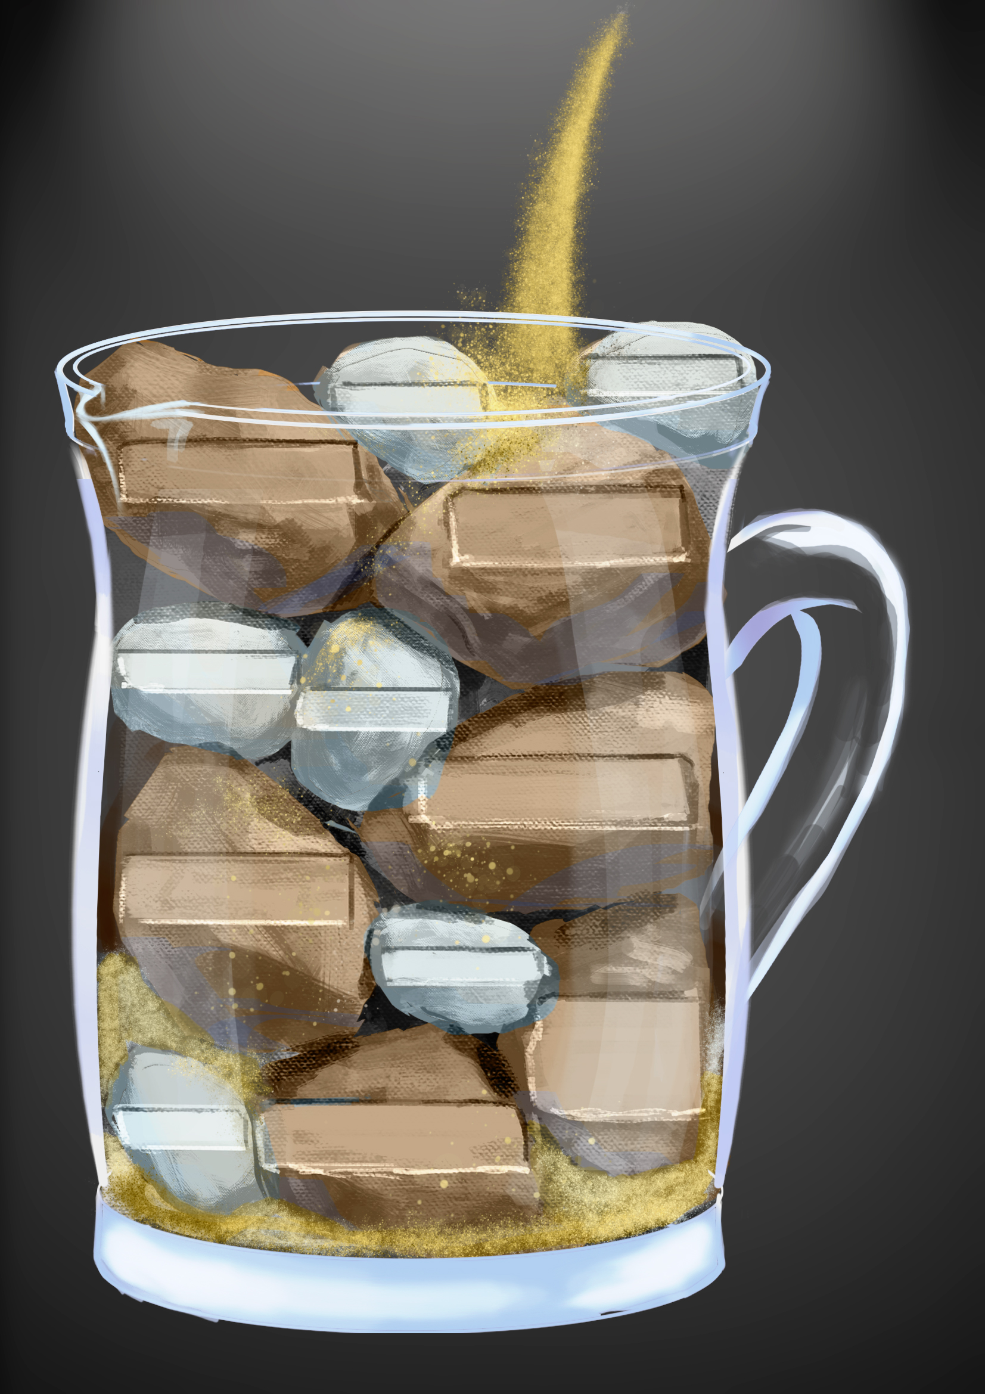
PICTURE THIS:
A trainer is addressing her class. She fills a jug with big rocks and asks the class if it's full. The class responds with a “Yes”. “Really? Lets see” she says and precedes to further add pebbles to the jug and again asks if the jug is full. The class responds and indicates that the jug is now full. The trainer again says “really? Lets see” She says “ The trainer then pours sand into the jug.
The trainer went on to explain that the sand and the pebbles represent the small daily tasks we fill our lives with. If we don’t fit our big rocks in first, our lives will fill with only sand and pebbles. BUT if we start with our big rocks, we create room for what’s important in life - and the sand and pebbles can only fill the spaces in between.
- Think about where are you currently spending most of your time?
- ______________________________________________________________________
- ______________________________________________________________________
- ______________________________________________________________________

- What is the LARGEST thing(s) that DRAINS your time at the moment?
____________________________________________________________________________________________________________________________________________________________________________________________________________________________________

- What changes are you going to make in regards to this? ________________________________________________________________________________________________________________________________________________________________________________________________________________________________________________________________________________________________________________

Now lets get really clear…
What are your Top 3 Priorities in life?
- ___________________________________________________________________
- ___________________________________________________________________
- ___________________________________________________________________

- What one thing is MOST IMPORTANT to you right now?_________________________

YOUR PERSONAL PRIORITY MANAGEMENT TOOL
Time to Reflect:
What changes will you make following what you have learned about yourself?
- How does where you currently spend your time compare to your "Priority Rocks" - your REAL priorities?
________________________________________________________________________________________________________________________________________________________

- What does this tell you? ________________________________________________________________________________________________________________________________________________________

What Needs to Change?
- What could you be doing differently?
________________________________________________________________________________________________________________________________________________________

4. What is the SIMPLIST change/s you could make to prioritise your time better?

________________________________________________________________________________
5. What are you PREPARED to change to prioritise your time better?

________________________________________________________________________________

6. Smash those hurdles:
What could get in the way? If you were going to sabotage yourself how would you do it?

________________________________________________________________________________

So the question really is, what will you commit to?

- What WILL you change or do differently? Take a look at the entire worksheet and identify 3 actions you will take to focus on your PRIORITY ROCKS in life:

1st Action ______________________________________________By when ____________

2nd Action _____________________________________________By when ____________

3rd Action _____________________________________________By when ____________
Put these actions all over the place, everywhere you will see them… Have them as a screensaver, on the bathroom mirror on the fridge and in your wallet… Set reminders on your phone to come up with these actions.

This is a contract you are entering with yourself. Do yourself proud.
I am committed to achieving these 3 actions!

Signed: __________________________________ Date: ______________________________

